**Chapter 6 - Say No To Drugs**

**All Lectures Uploaded on YouTube:**

[**https://tinyurl.com/fkm9-english**](https://tinyurl.com/fkm9-english)

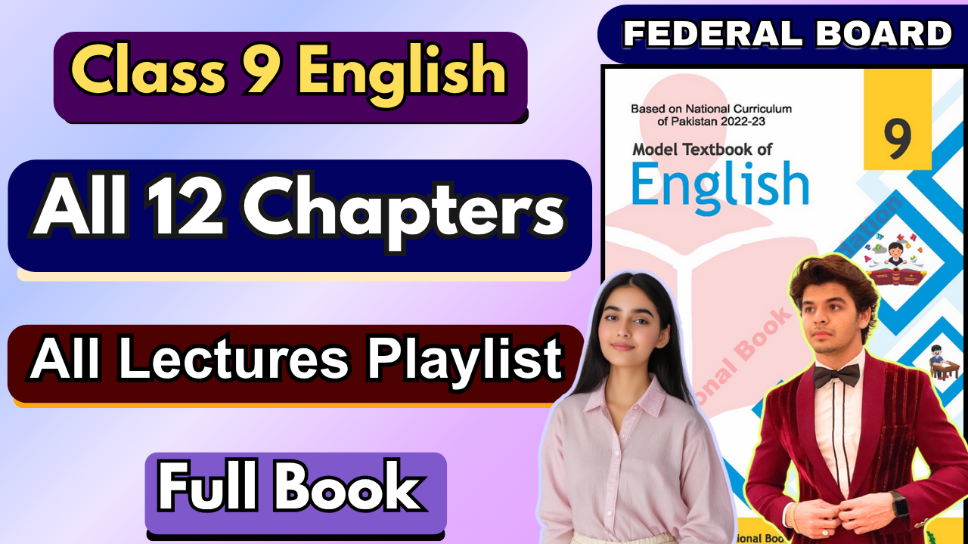

**Glossary:**

**Given below are the difficult words from the unit. Look at their meanings and use these words in your own sentences.**

| **Words** | **Meaning** |
| --- | --- |
| menace | something that is likely to cause harm or trouble |
| tremendous | remarkable or extraordinary in size or intensity |
| illicit | forbidden by law, illegal |
| momentary | lasting for only a brief moment |
| devastating | causing severe damage, destruction, or profound distress |
| addiction | a habitual or chronic dependence on a behavior, substance, or practice |
| inevitable | something that is bound to occur |
| prevention | the act of stopping something from happening or arising |
| substance | a drug, typically an illegal one |
| opioids | a class of drugs that includes pain relievers |
| prescription | a doctor’s instruction for the use of a specific drug |
| sober | free from the influence of intoxicating substances |

The following are the sentences for the above mentioned words:

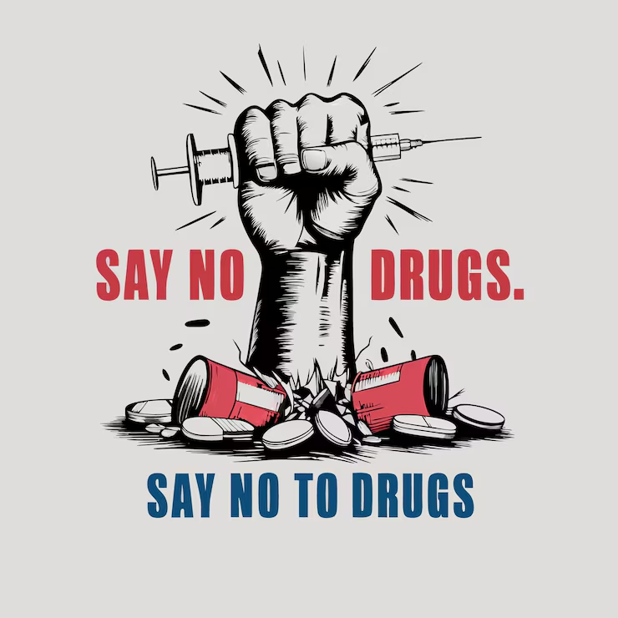

1. **Menace** – The rising number of drug dealers in the neighborhood has become a serious menace to society.
2. **Tremendous** – The new rehabilitation program has made a tremendous impact on reducing drug abuse.
3. **Illicit** – Police arrested the group involved in the illicit trade of narcotics.
4. **Momentary** – The feeling of relief after taking the drug was only momentary.
5. **Devastating** – The loss of her brother to overdose was a devastating blow to the family.
6. **Addiction** – Addiction can destroy relationships, careers, and even lives if left untreated.
7. **Inevitable** – Without proper awareness and support, relapse becomes almost inevitable.
8. **Prevention** – Education plays a key role in the prevention of substance abuse.
9. **Substance** – Many young people are unaware of the dangers of experimenting with any harmful substance.
10. **Opioids** – The misuse of opioids has caused a public health crisis in many countries.
11. **Prescription** – Patients should never take prescription drugs without a doctor’s guidance.
12. **Sober** – After months of treatment, he finally managed to stay sober and rebuild his life.

**Reading and Critical Thinking Skills**

**A. Reading Comprehension Questions:**

## Q1. How does the text illustrate the cause-and-effect relationship between community-based initiatives and the prevention of drug abuse?

**Ans.** The text explains that community-based initiatives, such as anti-drug awareness campaigns and collaboration with educational institutions, help educate people about the dangers of drug abuse. This knowledge empowers individuals, particularly the youth, to stay away from drugs. The initiatives lead to a decrease in the prevalence of drug addiction by addressing its root causes and providing education and resources to prevent substance abuse.

**Q2. Write the causes and effects of substance abuse among athletes, as illustrated in the text, drawing insights from the personal journeys of individuals. How do their personal experiences provide valuable perspective on the hurdles and outcomes associated with addiction in their lives?**

**Ans.**

**Causes:**

* Stress and injuries lead to dependency on painkillers or substances.
* Peer pressure or trying to manage conditions like anxiety or disorders (e.g., Anthony Ervin).

## Effects:

* Loss of career opportunities (e.g., Josh Hamilton's suspension).
* Struggles with relapses (e.g., Hamilton relapsed several times).
* Need for rehabilitation and rebuilding life (e.g., Brett Favre and Chris Herren overcoming addiction).

These personal experiences highlight the difficulties faced in battling addiction and underline the importance of persistence, support, and community initiatives in achieving recovery. They also serve as inspiration for others struggling with addiction, proving that recovery is possible.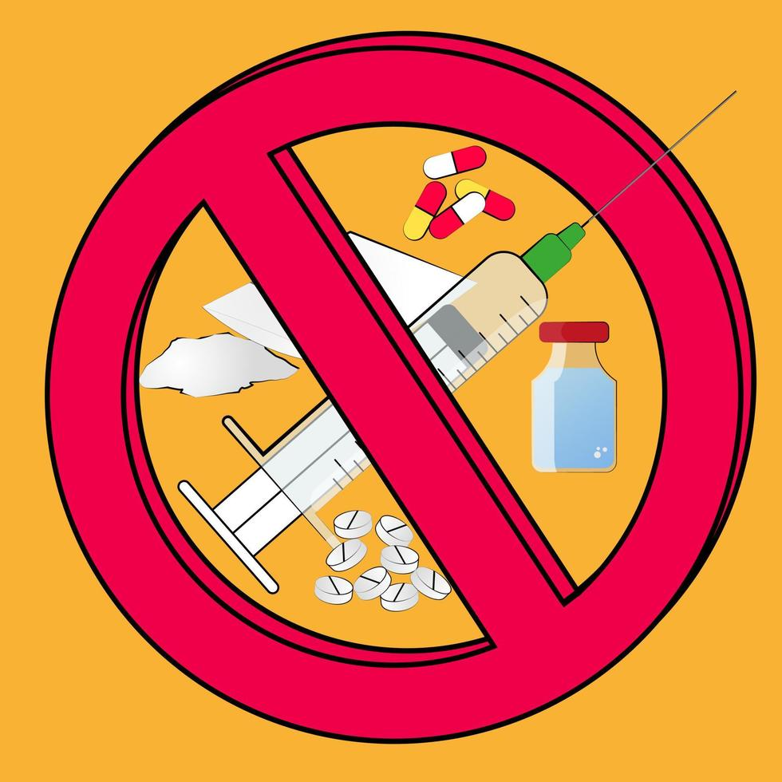

## Q3. How does the text emphasize the importance of protecting the youth from drug addiction, and what specific initiatives are mentioned to achieve this goal?

**Ans.** The text stresses that youth are Pakistan's greatest asset and highlights the need to safeguard them from the dangers of drug addiction to secure the future of the country. Specific initiatives include:

* Nationwide anti-drug awareness campaigns.
* Collaborations between public and private educational institutions.
* Programs by the Anti-Narcotic Force to educate people at national and international levels.

These efforts aim to keep the younger generation informed and away from the harmful effects of drugs.

## Q4. Why is it significant for Pakistan to collaborate with public and private educational institutions in launching nationwide anti-drug awareness campaigns, as mentioned in the text?

**Ans.** Collaboration is crucial because it ensures widespread reach and impact. Public and private educational institutions are central to shaping young minds and can effectively deliver anti-drug education. By working together, these institutions can prevent addiction at an early stage and promote a healthier, drug-free lifestyle among the youth, contributing to the overall well-being of society.

## Q5. What message is the text conveying about addiction? What steps are suggested for those who may be suffering from addiction?

**Ans.** The text conveys that addiction is a serious issue that affects everyone regardless of status or background. It emphasizes that no one is immune, and recovery is possible with determination and support.

## Steps suggested:

* Recognize the problem and seek help.
* Engage in community-based programs and rehabilitation.
* Educate and inspire others about the importance of living a sober life

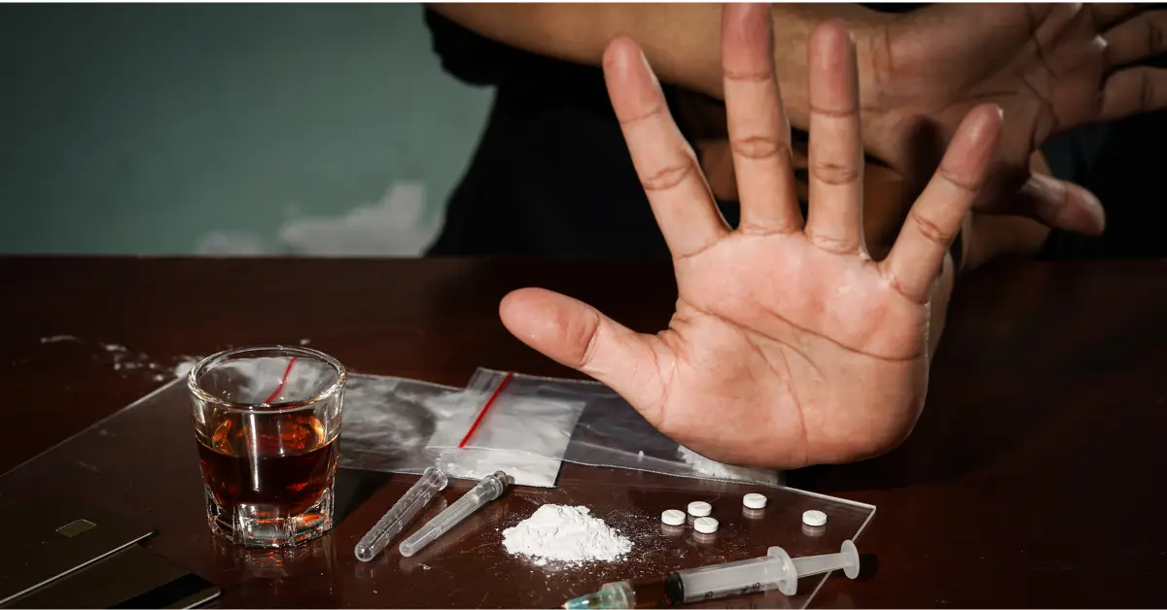

# Grammar Section:

## Q1. Correct the following text

It was the best of times it was the worst of times it was the age of wisdom it was the age of foolishness it was the epoche of belief it was the epoche of incredulity it was the season of Light it was the season of Darkness it was the spring of hope it was the winter of despair we had everything before us we had nothing before us we were all going direct to Heaven we were all going direct the other way, in short, the period was so far like the present period that some of its noisiest authorities insisted on its being received for good or for evil in the superlative degree of comparison only.

## Ans.

## Revised Text:

It was the best of times; it was the worst of times. It was the age of wisdom; it was the age of foolishness. It was the epoch of belief; it was the epoch of incredulity. It was the season of Light; it was the season of Darkness. It was the spring of hope; it was the winter of despair. We had everything before us; we had nothing before us. We were all going directly to Heaven; we were all going directly the other way. In short, the period was so far like the present period that some of its noisiest authorities insisted on its being received, for good or for evil, in the superlative degree of comparison only.

# From The Human Seasons by John Keats:

## Q. Analyze the poem's organizational patterns and answer these:

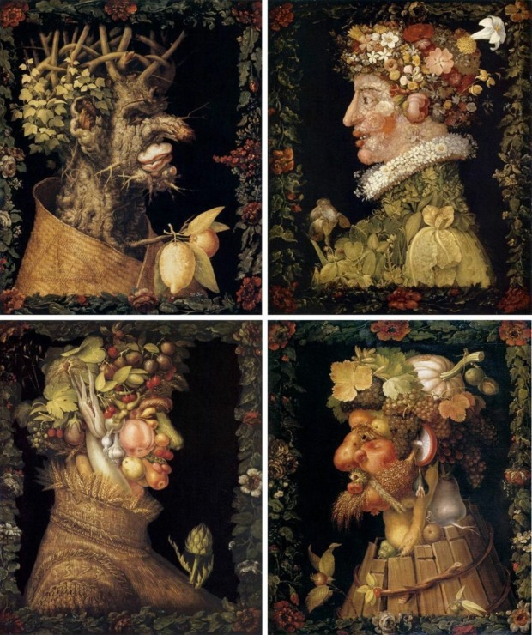

1. **Identify the sequence of ideas/events and their contribution to meaning:**

**Ans.** The poem divides the stages of life into the four seasons:

* 1. **Spring:** Symbolizing youth, marked by freshness, imagination, and susceptibility to beauty.
  2. **Summer:** Representing manhood, a phase of luxuriating in thoughts and dreams, aspiring towards higher goals.
  3. **Autumn:** A time for reflection and contentment in middle age, characterized by an acceptance of the transience of beauty.
  4. **Winter:** The final stage, depicting old age with its infirmities and decay, reminding us of mortality.

This sequence mirrors the human lifecycle, using seasons as metaphors for the stages of life. It underscores how life transitions naturally through periods of growth, flourishing, reflection, and decline.



## Cause-effect relationships and their role:

**Ans.** The poem reflects the inevitable progression of life, where youth's curiosity leads to the maturity of thought, and eventually, age brings wisdom and acceptance. The interplay between stages is natural and inevitable, reinforcing the poem's message about the cyclic nature of life and mortality.

## (c) Investigate if there are elements of problems and solutions within the poem and explain their significance to the overall theme or message of the work.

**Ans.** In "The Human Seasons," the problems and solutions are embedded in the natural cycle of life:

## Problems:

* + Each stage of life presents its unique challenges:
    - **Spring (Youth)**: The challenge is the naive susceptibility to beauty and lack of experience.
    - **Summer (Manhood)**: Dreams and ambitions can lead to striving for unattainable goals.
    - **Autumn (Middle Age)**: A sense of detachment from life's vibrancy may cause melancholy or indifference.
    - **Winter (Old Age)**: Decay, physical infirmity, and the inevitability of death weigh heavily on the individual.

## Solutions:

* + Each stage also provides its own resolution or acceptance:
    - **Spring**: Embrace the wonder and curiosity of youth while learning.
    - **Summer**: Luxuriate in aspirations and dreams that elevate the spirit.
    - **Autumn**: Accept life’s transience and find contentment in simplicity and reflection.
    - **Winter**: Accept mortality as a natural part of life’s cycle, appreciating the wisdom and peace it brings.

These problems and solutions highlight the inevitability of life’s transitions. By framing each stage with its unique difficulties and resolutions, John emphasizes life's cyclical, balanced nature. The poem ultimately suggests that life is complete and meaningful when one embraces each phase with its joys and challenges, leading to a harmonious acceptance of mortality.

